**Chinook Store Analysis**

Ran Tun

U04777023

AD 599: Introduction to Python and SQL for Business Analytics

08/06/2021

**Salesperson to Promote**

The owner of the Chinook Store was looking to promote a salesperson to sales manager. The one issue with this is that there were no formal metrics to work with or historical measures to observe. The current sales manager has no sales data or KPI’s in any sense. Using the database and some intuition, the best person to promote would be Jane Peacock, employee 3. The thought process behind choosing Jane was creating metrics that capture a number of sales, average invoice total, and total amount of sales. With the given data, it is not at all possible to determine rates of conversion. Three sales representatives were analyzed, and the top candidate was chosen. Jane led the race in two out three categories, with Steve beating her in the average invoice total. Margret Park was a close second. Had there been a tie, another unit of measurement that could have been implemented would be the number of customers helped. To repeat had there been a metric for conversions, meaning customers that went from “browsing” to purchasing, it would have superseded most of the other metrics. Conversion is a crucial part of sales capability when paired with the number of customers.

**Frequency of Visits**

Another critical factor is to look at how often customers return to the store and purchase items. According to the histogram (a) created, see appendix below, most customers visited between 100 and 200 days, followed by 300 to 400, then the least coming between 400 and 600 days. The 59 customers shopping with the company do not visit often; however, this is not too bad given the nature of music and its production time, but from a business standpoint, if only 59 customers are returning every 100 to 200 days, there is a clear issue, especially since these items are on the cheap side. The owners should try to engage a new group with the given data, but more on that later.

**Metrics to Consider**

Metrics are an essential piece when measuring business success and health. The first general metric to look at involves countries and their spending. Figure b displays a table in order of sales per capita. This information is useful when considering advertisements. On the table, Chile is ranked #1, with only one order, while the USA is ranked #7 with thirteen orders, a true example of quality over quantity. This metric can be used to target specific regions and countries to encourage more sales. However, this would have owners prioritize something that may have been a one-time deal.

An additional metric measures the top 10 genres in the United States. Given the number of customers, there may need to be an increased stock in specific genres. See appendix c for the entire table. The most popular genre is Rock; however, times change. Rock was at its peak in the 1950s. So, these customers may be older, and while all ages can enjoy Rock, the general assumption here would be that the group shopping at this store is on the older side. These metrics allow the store to shift as needed and help attract a new crowd to replace the older one. The one challenge this list faces is that the new generation of music consumption revolves around streaming, so a list like this may stay as-is.

The last metric to consider would be a “Top Hits” list. These can easily be marketed as must-have music for the average music collector. The list is also unique in the sense that it is derived from customer sales, so it is almost personalized to the customers. It serves as a “you liked this song; you may like this one.” One con is that the list is comprised of the customers, meaning the list is made of sales data, meaning most top tracks may not sell as well due to the fact that they were already purchased.

**Appendix**

1. 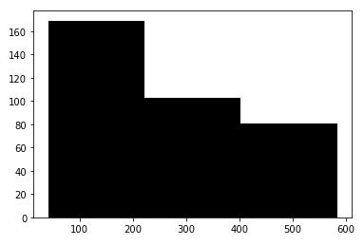
2. 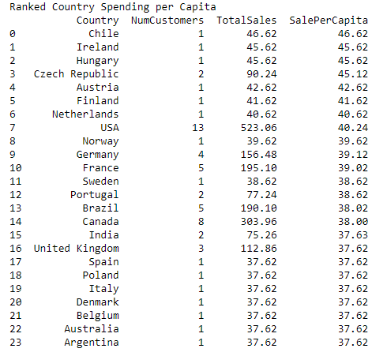
3. 